CLASSIFIED
Copy __1___ of __1___
Armor and Mechanized Infantry Task Unit
1st Battalion, 7th Cavalry Regiment
1st Armored Brigade Combat Team
1st Cavalry Division
081800ZAPR18

OPERATIONS ORDER (OPORD):
JUNIPER SPEAR
BATTALION TO TASK UNIT OPERATIONS ORDER
REFERENCES:
- Area of Interest Overlay
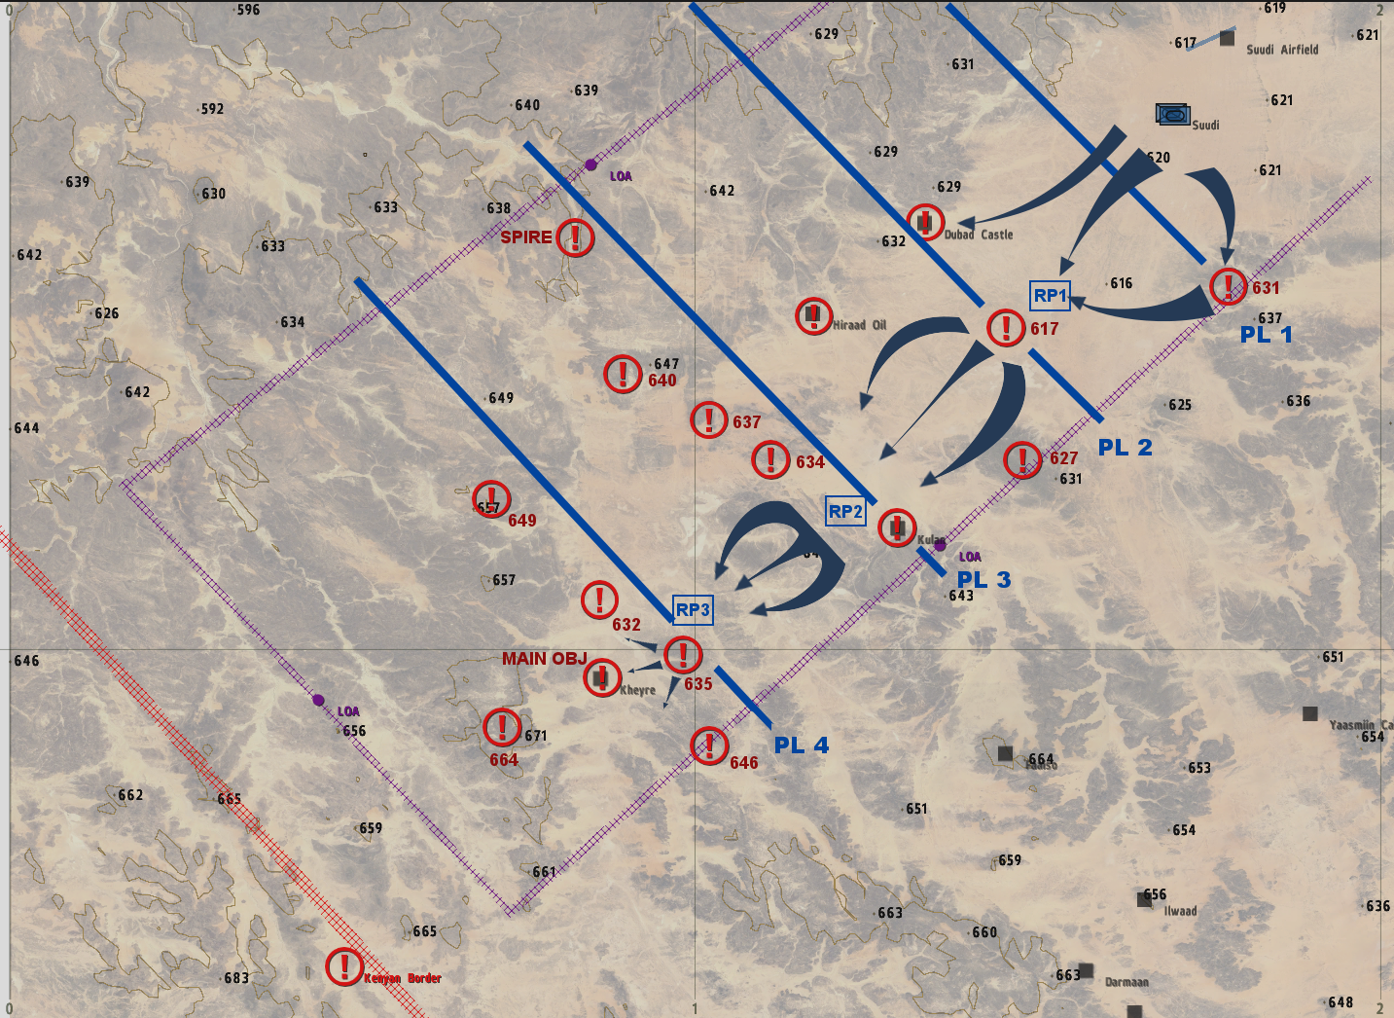
Task Organization:
VIKING PLATOON: Mechanized Infantry Platoon (Bradley M2A3, MRAP)
SABRE PLATOON: 4 x M1A2 Abrams Tanks
APOLLO: Operations Support Grp
INFIDEL-1: Drone Surveillance
- Situation.
During an aerial recon along the Kenyan border, NATO troops identified a number of Al-Shabaab camps and positions stretching the length of the border. Among the targets was what appears to be two major weapons caches; one at Kheyre and one at Darmaan.
  - Enemy Forces.
    - Weather and light data general forecast for the length of the operation:
High Temp: 30 Celsius
Low Temp: 24 Celsius
Sunrise: 0300 Z+3
Sunset: 1900Z+3
Overall Weather: CLEAR, SUNNY
Illumination (Night): HIGH
    - Terrain (OCAKA):
      - Observation and Fields of Fire (FOF) are superior for entrenched enemy forces equipped with static ATGMs, a mix of T-55 and 1984 T-72s and technicals. Enemy forces are located in slightly elevated positions overlooking relatively flat terrain.
      - Cover and Concealment is optimal for OPFOR entrenched in and around the objectives.
      - Obstacles have not been observed, however the terrain is undulating and very rocky, limiting speed and direct routes.
      - Key or Decisive Terrain for this mission are the elevated, entrenched positions along the flanks of the route of advance and the main objective at Kheyre.
      - Avenues of Approach for OPFOR are from the north of the route of advance.

    - Identification of enemy forces (composition). The OPFOR heavy assets that were seized from the 3rd Brigade, SNSF are stationed in and around border area as denoted on the overlay. OPFOR is also equipped with crew served weapons, along with motorized assets.
    - Location(s):
      - Phase Line One - Camp 631: Elevated position with static ATGMs and 2 X BTR-60.
      - Phase Line Two - Camp 617 and Dubad Castle: Initial line of resistance. Camp 617 known to contain ZSU-23-2 and static ATGM. Same at Dubad Castle. Hirad Oil: 1 X T-72, 1 X T-55
      - Phase Line Three - Camp 634 and Kulan: Static ATGM and 4 X BTR-60 at Camp 634. Static ATGM and 2 X BTR-60 at Kulan. Camp Spire: 3 X T-55, 4 X BTR-60 squads.
      - Phase Line Four - Camp 635/632/646: Camp 635: 1 X T-72, 5 X BTR-60 with squads, 1 platoon infantry, ATGM. Camp 646 2 X BTR-60 squads. Camp 632: 1 X T-72, 1 X T-55, 2 X BTR-60 with squads, 2 X Ural, static ATGM.
      - Objective Kheyre: 6 X T-72, 1 X T-55, 4 X BTR-60 squads, Platoon Infantry, Static ATGM, Large Weapons Cache.
    - Activity: OPFOR is garrisoned in and around the objectives, along with blockading likely avenues of approach. Any attempts to attack and occupy the objectives will likely be ambushed. OPFOR are reinforced by CSW and captured heavy SNSF assets (armored and mechanized).
    - Strength: OPFOR is entrenched in approximately heavy battalion strength in and around the area of interest.
    - Probable course(s) of action when contacted: OPFOR will likely remain in place and fight, and may attempt to counter-attack, and or make first contact through an ambush. Given relatively high morale, if decisively engaged, they will fight to the death, and likely not to surrender.
  - Friendly Forces.
    - Mission and concept of next higher unit: The Armored and Mechanized Task Unit assigned to 1st Battalion, 7th Cavalry will move from Suudi to Kheyre, securing it and destroying equipment and the large ammunition cache there.
    - Location and planned actions of units to the left, right, front, and rear: N/A
    - Units providing fire support:
      - Mortars: Not available.
      - CAS: Not available.
      - Artillery: Not available.
  - Attachments/Detachments.
    - Attachment: Infidel-1 with Drone.
    - Detachment: No detachments from BN HQ.
- Mission.
The Armored and Mechanized Task Unit assigned to 1st Battalion, 7th Cavalry will move from Suudi to Kheyre, securing it and destroying equipment and the large ammunition cache there.
- Execution.
The intent is to push hard along the southern limit of advance until reaching Kheyre, bypassing fixed positions with a tank section on each flank and only dismounting to assault the strong points at Camp 617, 635 and finally the objective at Kheyre.
  - Concept of the Operation: The Task Unit will move from Suudi to RP1 to assault Camp 617, then reorg at RP2. It will then advance to RP3 to set up the assault on Camp 635 and the final drive onto Objective Kheyre.
- Maneuver: The mission will consist of the following movements:
  - Movement from Suudi to RP 1. One section of tanks on each flank will move independently but on line with the mechanized forces, engaging units from Camp 631 and Dubad Castle while remaining moving forward.
  - Maneuver from RP1 to Camp 617. Tank sections will flank 617 while the mechanized forces dismount and overwhelm the camp.
  - Move from Camp 617 to RP2. Unit will push straight to RP 2 avoiding decisive engagement.
  - Move from RP2 to RP3 in preparation for assault on Camp 635. Tank sections will flank 635 and provide flank security.
  - Maneuver from 635 to Objective Kheyre. Tanks on flanks, infantry in the center will conduct a frontal assault on Kheyre with Bradley’s as SBF.
  - Destroy all OPFOR assets at Kheyre.
  - Hold for further orders.
- Fires: N/A
  - Tasks to Maneuver Units.
- Reconnaissance will be conducted by motorized / mechanized / dismounted infantry.
- Security, R&S, EPW, Aid and Litter, and demolition will be handled by the Apollo.
  - Tasks to Combat Support Units.
    - Mustang will be deployed in 1 X MRAP.
    - Repair, Rearm and Refuel will be provided by APOLLO using HEMMT.
    - Infidel-1 will provide drone reconnaissance support.
  - Coordinating Instructions.
    - Order of movement, formations, and movement techniques.
      - Viking Platoon will drive directly south-west from Suudi in the center in Platoon Column. Tank sections will move in line on each flank. Apollo, Mustang and Infidel will move in the center rear of the column remaining close to avoid being engaged by roaming patrols.
      - ROE: All call-signs are weapons free from leaving Suudi. All contacts should be presumed to be hostile. No civilians have been observed in the area.
    - Actions at halts (short/long). SOP.
    - Routes (primary/alternate). Per overlay.
    - Departure and reentry of friendly lines. N/A
    - Rally points and actions at rally points. Viking units will set security at RPs. Sabre units will remain detached, providing flank security.
    - Actions at danger areas. SOP.
    - Actions on enemy contact. React to Contact. Execute appropriate battle drill.
    - Reorganization and consolidation instructions. Consolidate on objectives if possible.
    - Fire distribution measures. SOP.
    - Fire control measures. Engage the greatest threat first.
    - MOPP levels. MOPP Ready.
    - Troop safety and operational exposure guidance. Nuclear radiation may be present around the WMDs. Likelihood of triggering WMDs low, although they may be trapped. Use extreme caution.
    - Time schedules (rehearsals, backbriefs, inspections, movement). TBD.
    - Priority Intelligence Requirements (PIR).
      - Location and disposition of friendly EPWs.
      - OPFOR composition and capabilities.
      - Locations of IEDs, VEIDs, and other ambush sites.
      - Location of WMDs and/or Umar.
    - Debriefing requirements. See PIR above.
    - Reports. ACE and SALUTE reports after all OPFOR contact, SALUTE upon observation of all OPFOR.
    - Rules of Engagement (ROE). Mission outcome requires swift and deadly action utilizing heavy assets. Engage upon confirmation of PID. Attempt to minimize civilian casualties.
- Service Support.
  - General.
    - SOPs in effect for sustainment operations. None.
    - Current and proposed trains/resupply/cache points. RPs.
    - Casualty and damaged equipment.
      - CCPs to be established by platoon medical or Mustang
      - MEDEVAC/CASEVAC PZ to be designated PRN by Apollo or Mustang
    - Special instructions for Re-insert. Apollo will conduct reinserts by 2 X MRAP operating in relays.
  - Material and Services.
    - Supply:
      - Class I: SOP.
      - Class II: SOP.
      - Class III: SOP.
      - Class IV: N/A
      - Class V: Ammunition will be resupplyable via ground transport from Apollo from basecamp. Extra munitions will be carried within Apollo resupply trucks.
      - Class VI: N/A.
      - Class VII: SOP.
      - Class VIII: SOP.
      - Class IX: SOP
      - Class X: N/A.
      - Distribution Methods. SOP.
    - Transportation.
      - Ground.
        - 3x MRAP 1237 (M2) Vehicles for reinsert
        - 1x HEMMT Fuel
        - 1x HEMMT Ammo
        - 1x HEMMT Repair
      - Air: Not available
    - Services. SOP
    - Maintenance (weapons, equipment, vehicles). N/A.
  - Medical Evacuation: Casualties need to be treated in field. In event of critical wounded, CASEVAC will be provided by MRAP back to FOB.
  - Personnel:
    - All reinserts will be coordinated through S3 Officer in Charge (Apollo) and Apollo units,
    - All EPWs will be detained, searched, and cleared of all weapons and equipment and left along MSR SPEARHEAD for follow up security patrol
  - Miscellaneous:
    - Special equipment. None.
    - Captured equipment. Destroy in place, unless strange or unique. In case of strange or unique, case with or if can’t be moved make a sketch and destroy it.

- Command & Signal.
  - Command.
    - HHC 1ABCT is based out of FOB [Classified], Kismayo.
    - Battalion CP located at FOB Afmadow, Mogadishu.
    - Succession of Command.
      - S3 Officer in Charge (Apollo-6)
      - Mechanized Infantry Platoon Leader (Viking-6)
      - Mechanized Infantry Platoon Sergeant (Viking-7)
    - Adjustments to the unit SOP. None.
  - Signal
    - SOI. Standard SOI per Battalion.
    - Method of communication by priority. Short-range radio, Long-range radio, runner.
    - Pyrotechnics and signals. SOP + SL & up fix IR strobes during CAS
    - Codewords. None.
    - Challenge and password (behind friendly lines). Grind / Safety
    - Number combination (forward of friendly lines). 12
    - Running password. Garry Owen.
    - Recognition signals (near/far, day/night). Any combination of 3 lasers.
    - Special instructions for RTOs. None.

AUTHENTICATION 1LT Argus, J.
S3 Officer in Charge

